APPENDICES
The appendices provide supplementary information related to the design, development, and testing of the AKIRA (Accessible Knowledge & Information Retrieval Assistant) project. These materials include database design, API specifications, selected code excerpts, screenshots, sample inputs and outputs, testing details, and software dependencies. They are included separately to maintain the clarity and continuity of the main report.
APPENDIX A: PROJECT FILE STRUCTURE
The project is organized into backend modules, frontend resources, database files, and testing utilities. Each component performs a specific function within the application.
File/Folder | Description
app.py | Main Flask application and REST API routes.
db.py | Database initialization and database operations.
wiki_service.py | Retrieves and processes Wikipedia content, summaries, key takeaways, and flashcards.
speech.js | Implements speech recognition, text-to-speech, and synchronized text highlighting.
pdf_service.py | Generates PDF study guides.
templates/ | Contains HTML templates for the user interface.
static/ | Contains CSS, JavaScript, and other frontend resources.
akira.db | SQLite database for search history and bookmarks.
test_akira.py | Automated tests for application functionality.
requirements.txt | Lists the Python dependencies, if included in the project.

APPENDIX B: DATABASE DESIGN
AKIRA uses SQLite to store search history and bookmarked topics. This allows users to revisit previous searches and access saved study material.
B.1 History Table
Field | Description
id | Primary key; automatically generated identifier.
query | Search query entered by the user.
mode | Search mode, with standard as the default.
created_at | Date and time of the search.
An index on created_at supports efficient retrieval of recent search history.
B.2 Bookmarks Table
Field | Description
id | Primary key; automatically generated identifier.
title | Title of the bookmarked topic; unique and required.
summary | Summary of the saved topic.
url | Source URL of the topic.
takeaways | Key takeaways stored as a JSON-encoded array.
created_at | Date and time the bookmark was created.
An index on title supports efficient bookmark lookup. The database schema separates search records from saved topics for easier retrieval and maintenance.
APPENDIX C: REST API SPECIFICATION
The Flask backend provides REST API endpoints that connect the frontend with search, storage, export, and health-check functionality.
Endpoint | Method | Purpose
/api/search | POST | Searches for a topic and processes the retrieved content.
/api/history | GET | Retrieves search history.
/api/bookmarks | GET/POST | Retrieves or saves bookmarks.
/api/export/pdf | POST | Exports study material as a PDF.
/api/export/markdown | POST | Exports study material as Markdown notes.
/api/health | GET | Checks application availability.
Sample Search Request
{
"query": "Machine Learning"
}
Illustrative Response Structure
{
"success": true,
"query": "Machine Learning",
"summary": "A concise summary of the retrieved topic.",
"takeaways": [
"Important concept one",
"Important concept two"
]
}
The response shown above is an illustrative example of the expected structure, not a captured response from a live execution. Actual fields and content may vary according to the implementation and search results.
APPENDIX D: SELECTED CODE EXCERPTS
This appendix presents short examples of the main implementation areas. Complete source code can be submitted separately if required by the institution.
D.1 Flask Application
The Flask application receives client requests and directs them to the appropriate service functions.
D.2 Database Operations
The database module manages the SQLite connection and operations related to search history and bookmarks. It supports persistent storage so that relevant records remain available across application sessions.
D.3 Speech and Accessibility Features
The frontend speech functionality uses the browser's Web Speech API. Speech recognition supports voice-based searching, while speech synthesis reads retrieved content aloud. Playback controls and sentence highlighting help users follow the content while listening.
D.4 PDF Export
The PDF service uses ReportLab to format retrieved information into a study document. Paragraph formatting and appropriate text escaping help maintain readable output across multiple pages.
APPENDIX E: SCREENSHOTS AND SAMPLE INPUT/OUTPUT
This appendix contains screenshots of the running AKIRA application and examples of its input and output. Replace each placeholder below with a screenshot captured from the actual project.
Figure E.1: AKIRA Home Page and Search Interface
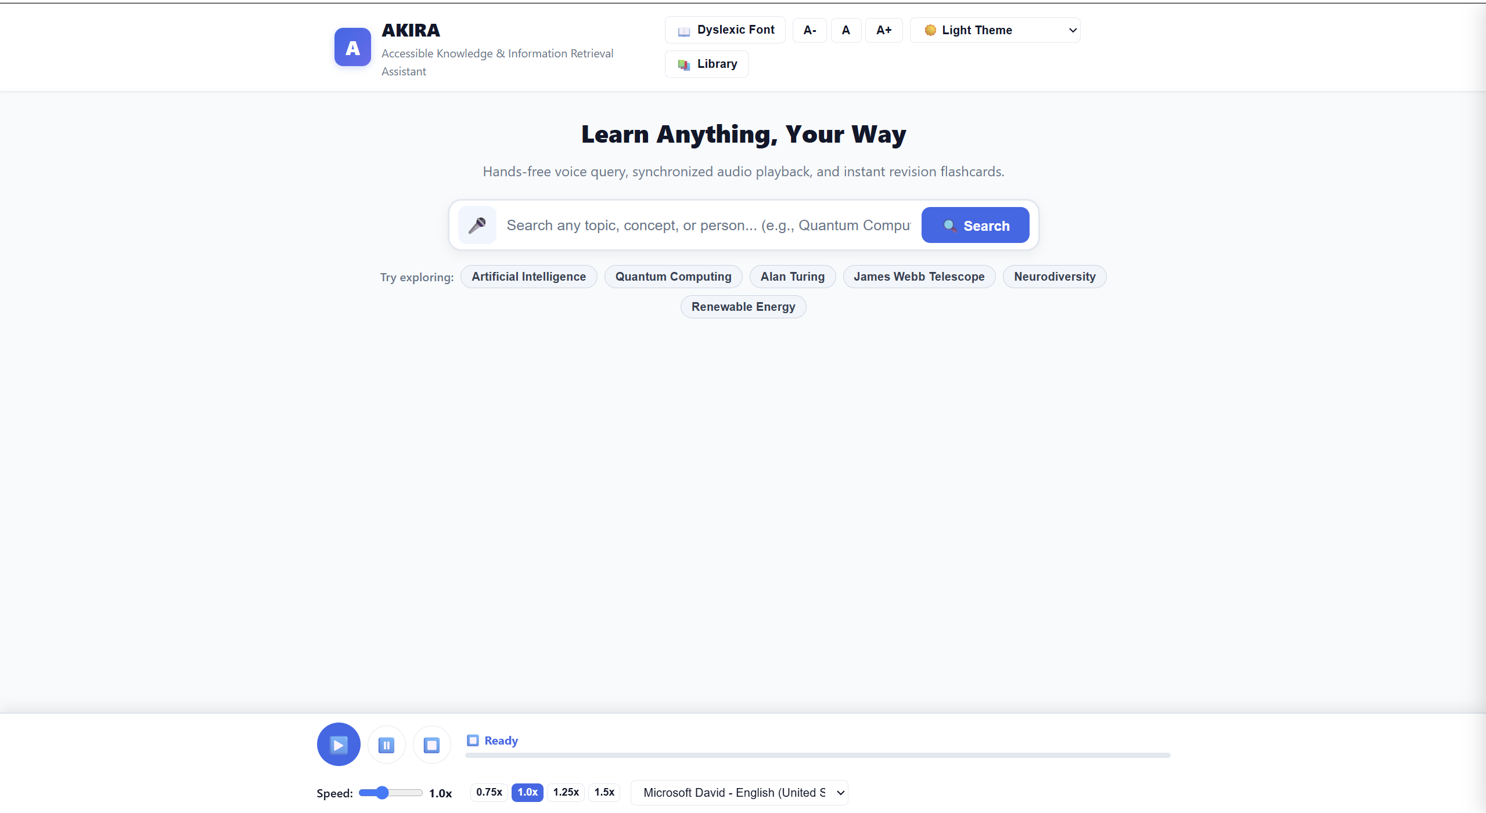Description: The home page allows users to enter a topic or query for information retrieval.

Figure E.2: Search Results and Study Content
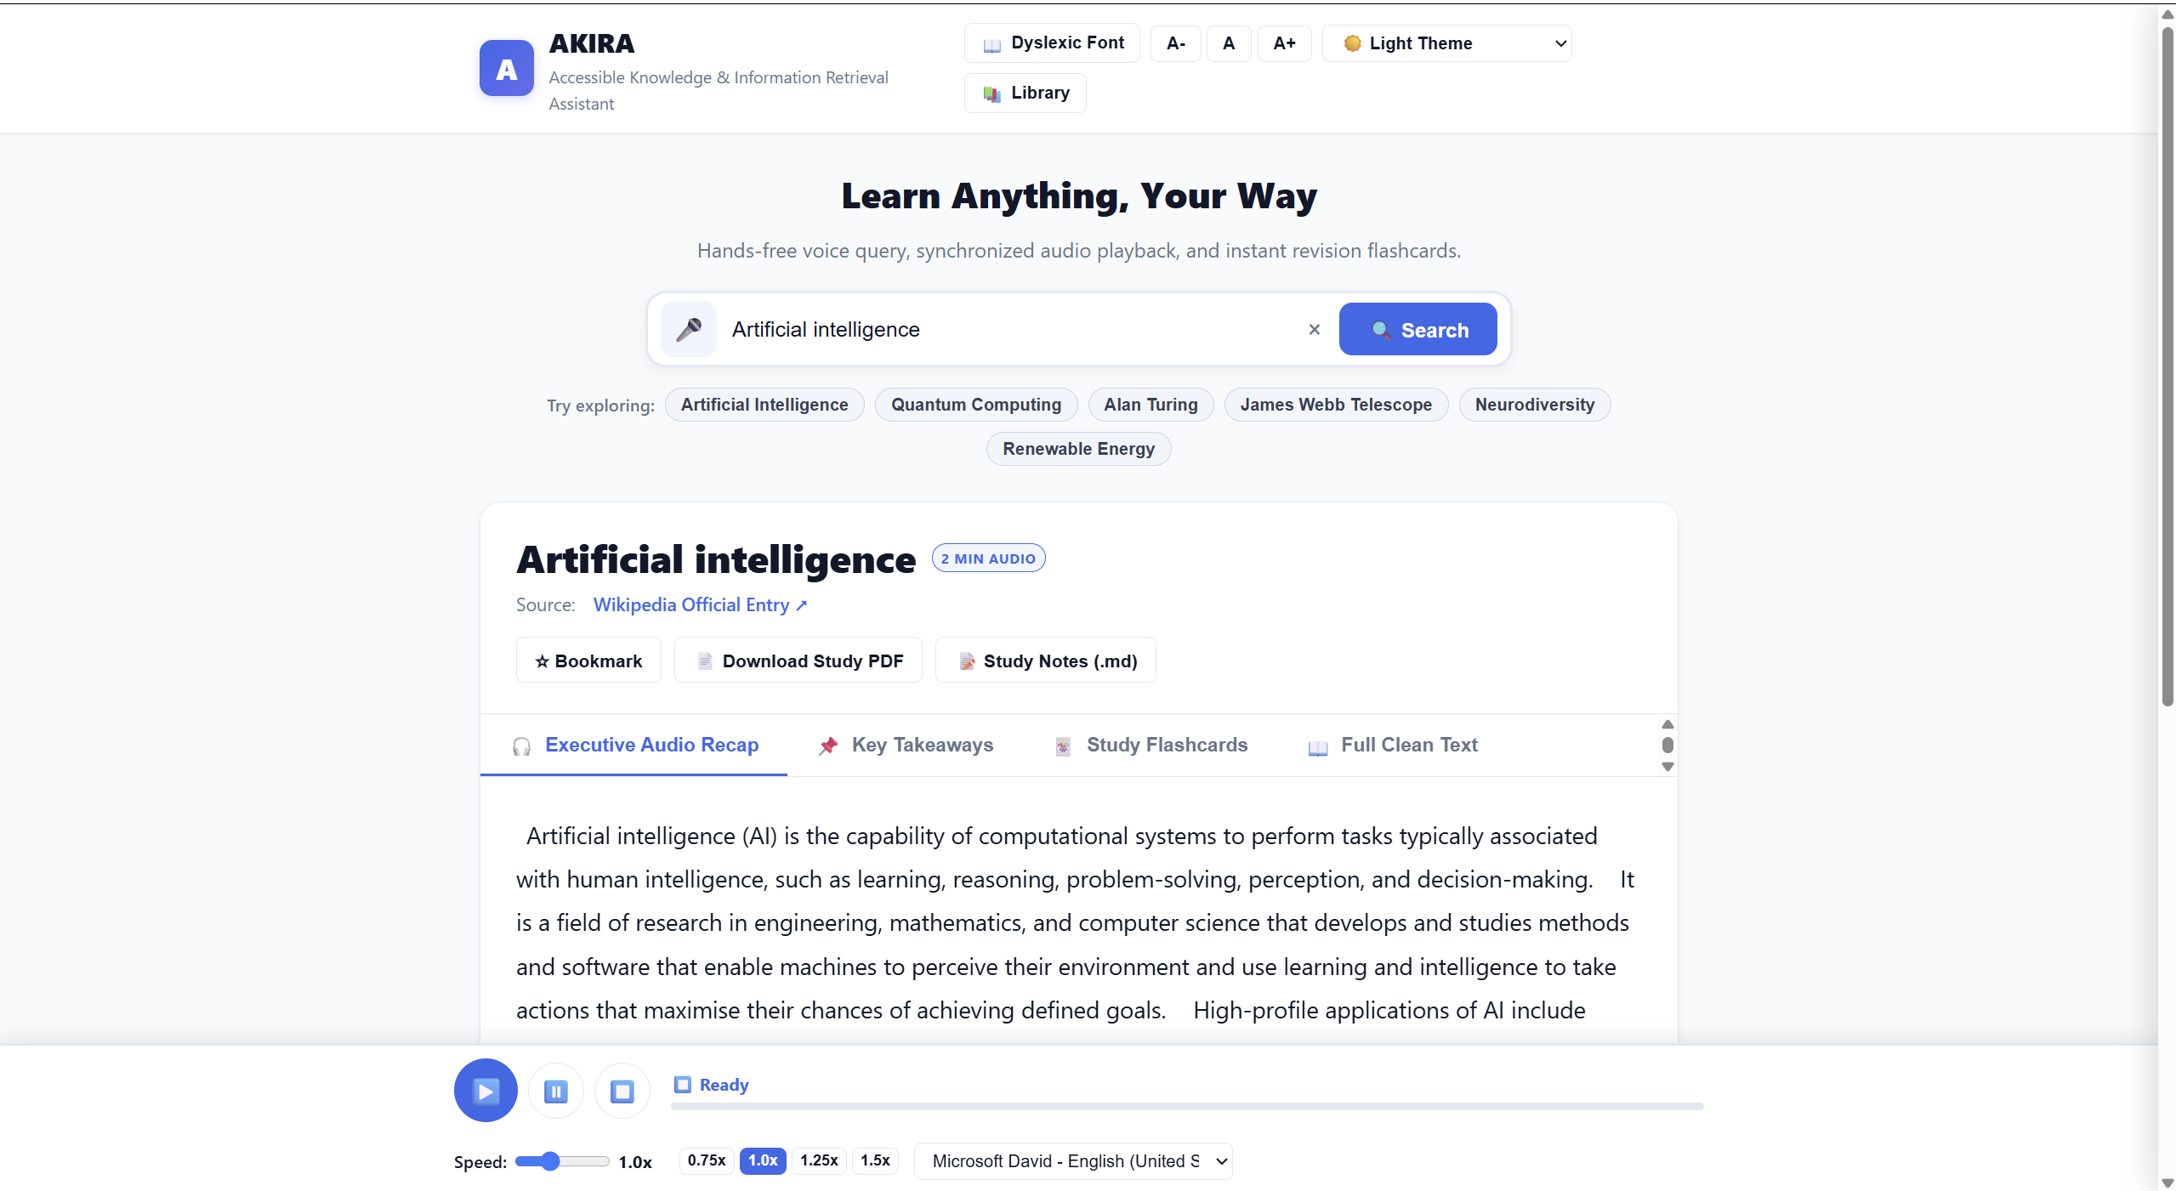
Description: The system presents retrieved information in a concise format to support learning and understanding.
Figure E.3: Text-to-Speech with Sentence Highlighting
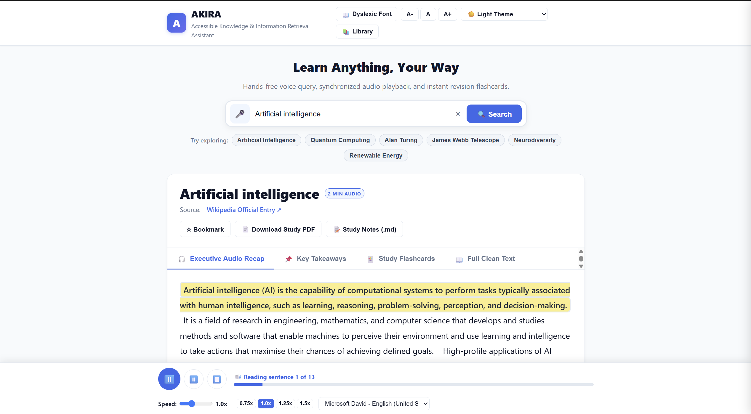
Description: The speech feature reads the content aloud and highlights the corresponding sentence.

Figure E.4: Interactive Flashcards
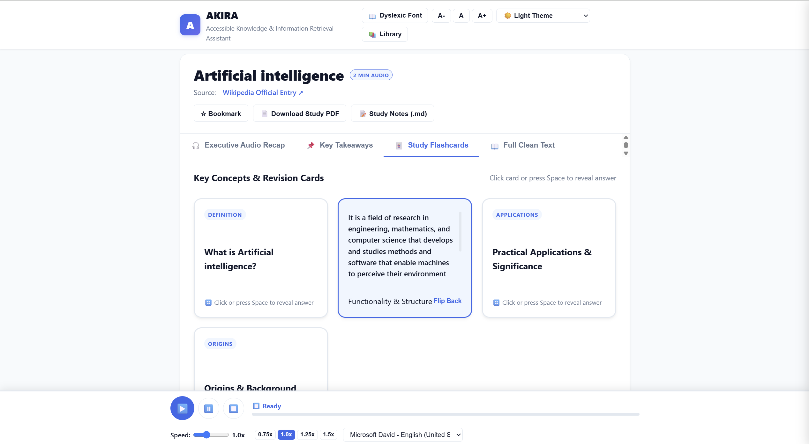Description: Flashcards help users revise important concepts through question-and-answer interactions.
Figure E.5: Accessibility Settings
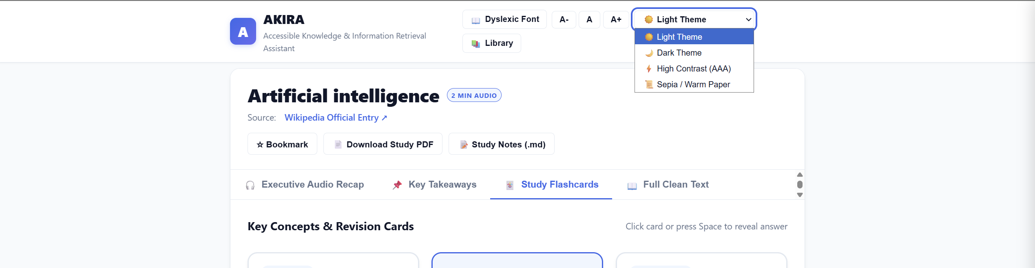Description: The interface provides display options to improve readability and accessibility.

Figure E.6: PDF Study Guide Output
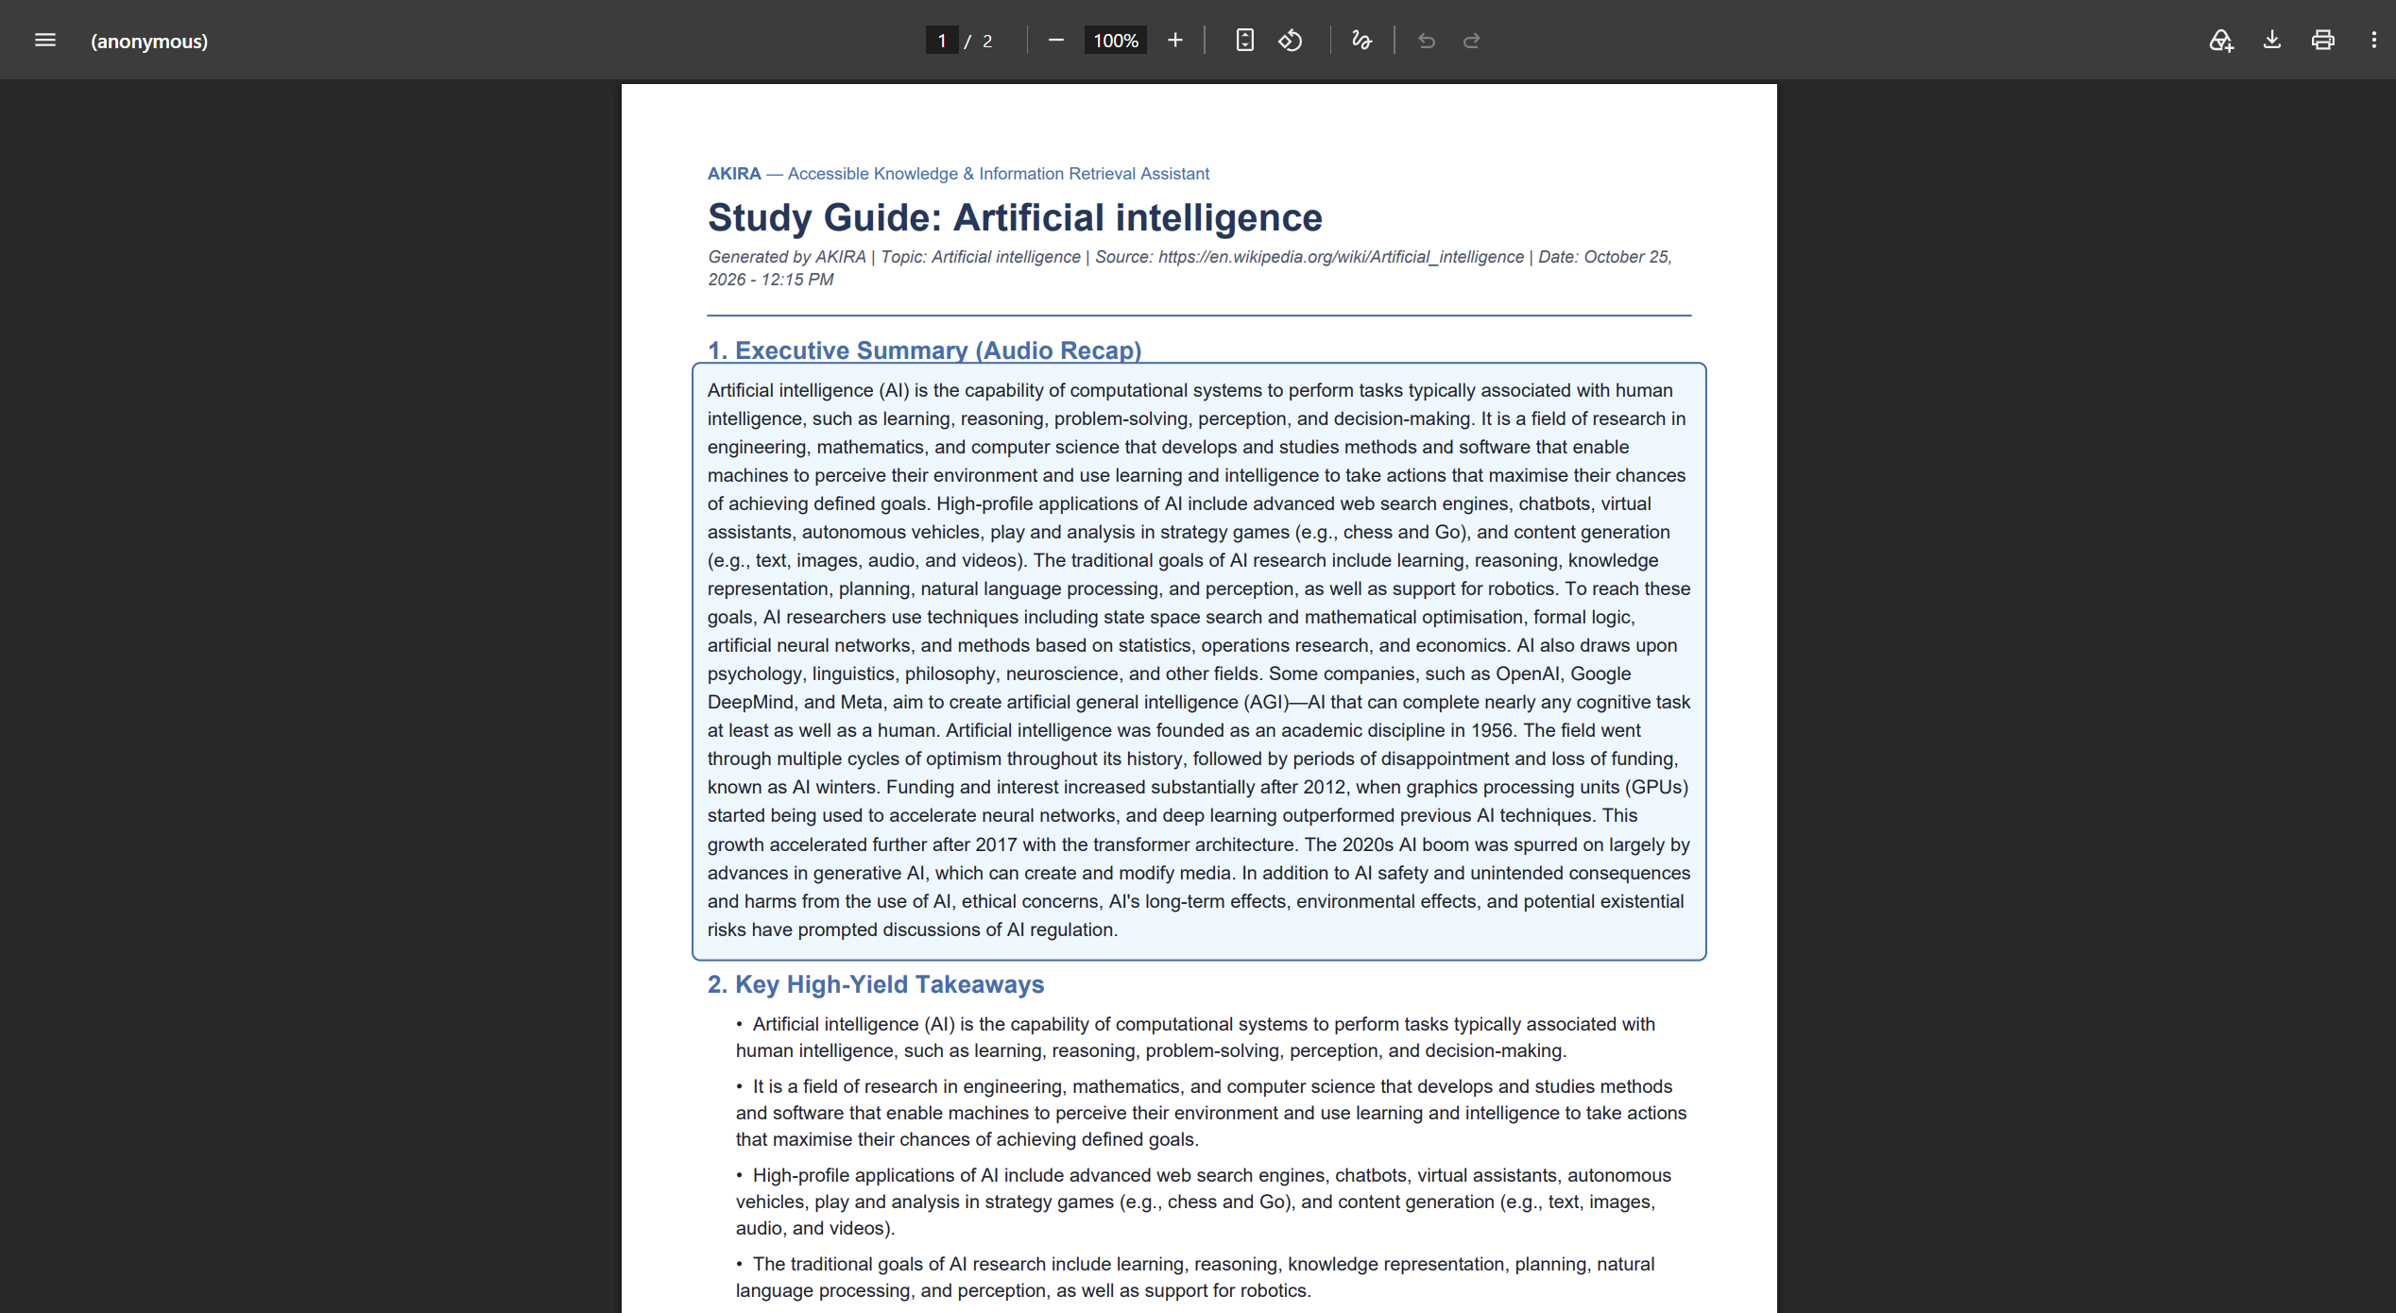Description: The export feature allows users to save study material for offline reference.
APPENDIX F: AUTOMATED TESTING
The project includes an automated test suite in test_akira.py to validate important application functions. The project documentation records 16 automated tests with a 100% pass rate for the tested version.
The tests cover application functionality and relevant service behavior. Testing helps identify errors, verify expected responses, and improve reliability during development.
Testing Area | Purpose
API functionality | Checks the behavior of supported application endpoints.
Search processing | Verifies search-related processing and response behavior.
Database operations | Checks persistence-related functionality.
Export functionality | Tests document-generation behavior.
Error handling | Checks the handling of invalid or unsuccessful operations.
The table summarizes testing areas. Include individual test names or execution logs only if they are available in the actual test suite.
APPENDIX G: SOFTWARE DEPENDENCIES
AKIRA uses the following technologies and libraries to provide its functionality.
Technology/Library | Purpose
Python 3 | Backend development and content processing.
Flask | Web application and REST API framework.
SQLite | Persistent storage for history and bookmarks.
Wikipedia/Wikimedia REST API | Retrieval of encyclopedia information.
ReportLab | PDF document generation.
HTML5 and CSS3 | Structure and styling of the user interface.
JavaScript | Frontend interactions and accessibility controls.
Web Speech API | Browser-based speech recognition and speech synthesis.
The project does not require paid third-party API subscriptions for its documented core functionality. Speech capabilities may vary depending on browser support and available voices.

